Add Basal Area to Project

In order to add basal area to your project, you will need two things: SPH and DBH. The SPH can be calculated using the tools in this program and the DBH should have been recorded for each tree. VTrees uses
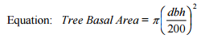
The result of this is multiplied by the SPH for the individual tree. Basal Area per HA for a plot is the sum of the BA for each tree in the plot. Basal area for the unit is an average of all the plots in the unit.

